Dated 24 -02-2024

Python Class day 1

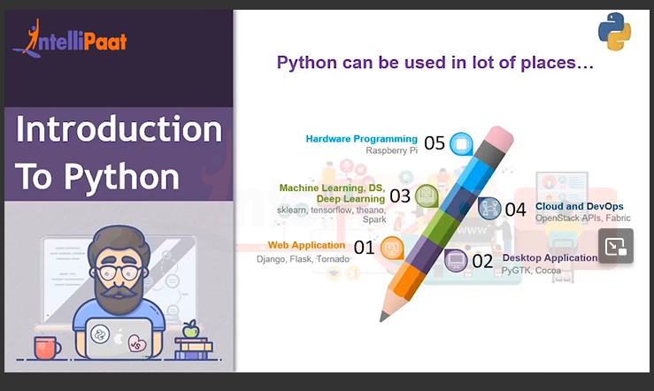

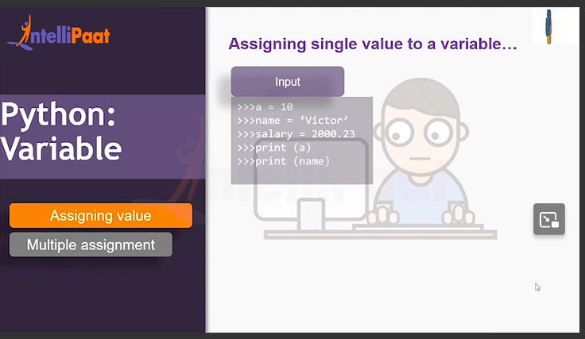

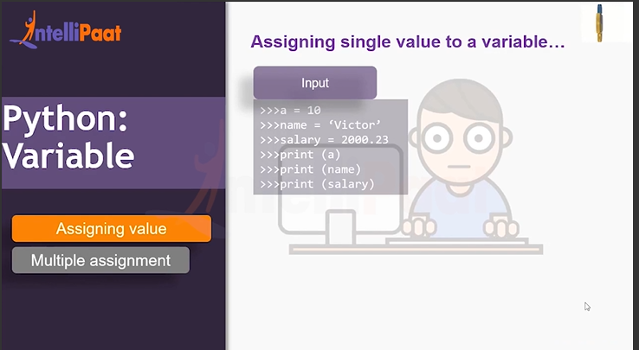

Lest see in the Jupyter Notebook  
in this case 10 = integer

Victor= String( datatype)

2000.23 = Floating datatype

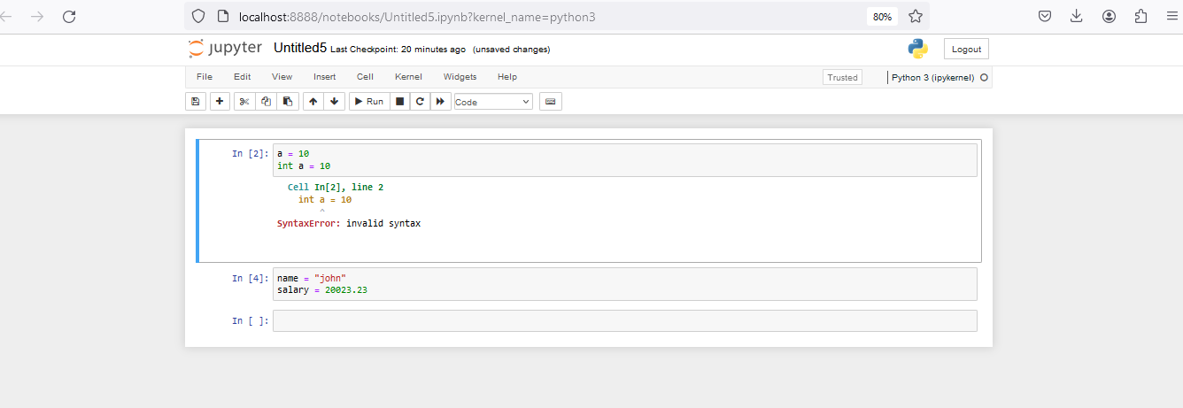

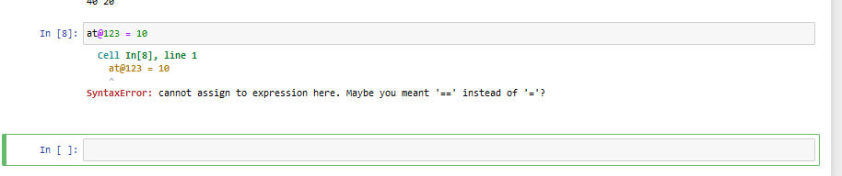

Python Class start here

Anaconda

Google colab

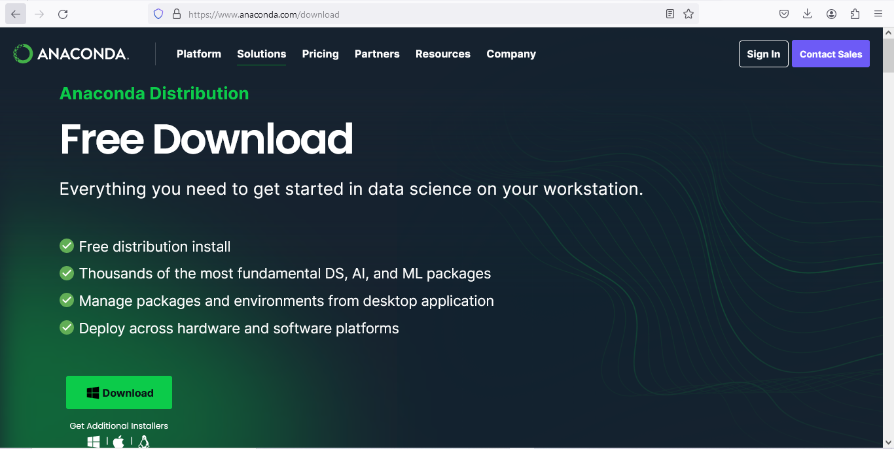

<https://www.anaconda.com/download>

OR

U can use google colab

https://colab.research.google.com/

<https://colab.research.google.com/drive/1-c9ymcvxSdTgj_cD7MICLcYGS3_ki9ZM#scrollTo=UZnD6sZHmB_s>

Now Jupyter

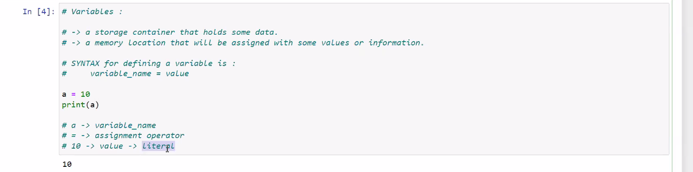

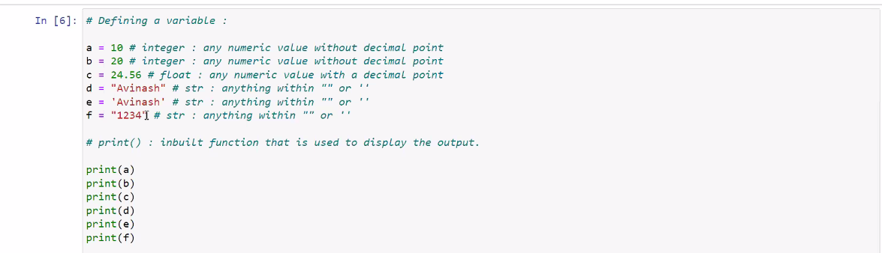

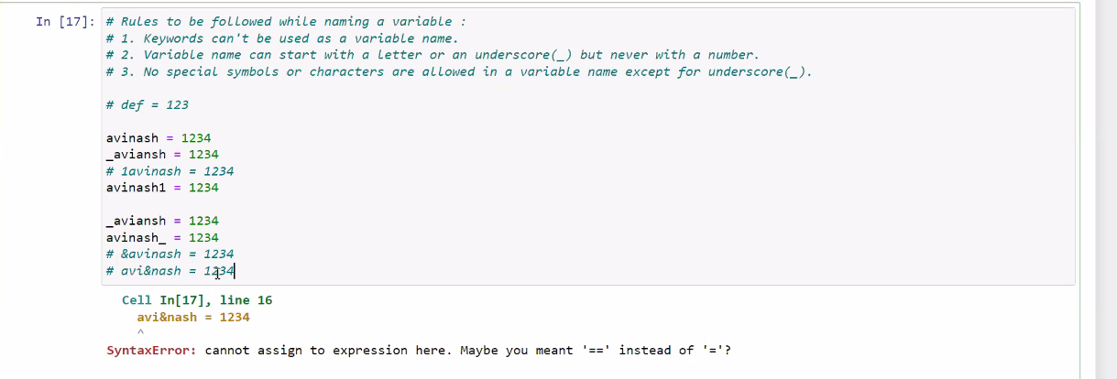

Box mean program is running ( \* )

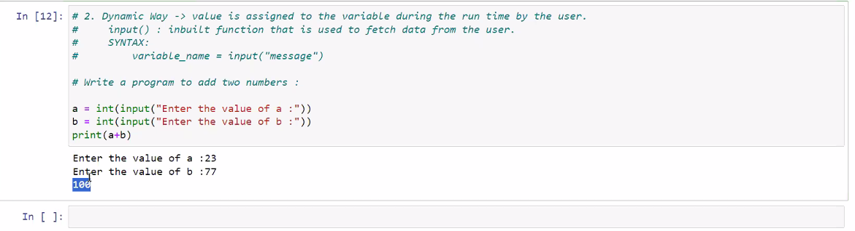

TOTAL 32 keyword in Python



